VARAIBLES :
A variable is a way of referring to a memory location used in a computer program. This memory location holds values- perhaps numbers or text or more complicated types of data like a payroll record.
The format for declaring a variable in C.
type data variable name [= initial value];

Constants :

The term constant means that it does not change during the execution of program. In the language C, constant and is the data with a constant value that does not change in the program.

There are four basic types of constants in C. They are:

1.Integer constants
2.Floating-point constants
3.Character constants
4.String constants
The following rule applies to all numeric type constants:
- Comma and blank spaces cannot be included within the constants.
- Constants can be preceded by a – or + sign, if desired. If either sign does not precede the constant it is assumed to be positive.
- The value of a constant cannot exceed specified minimum and maximum bounds. For each type of constant, these bound vary from one C compiler to another.
Integer Constants
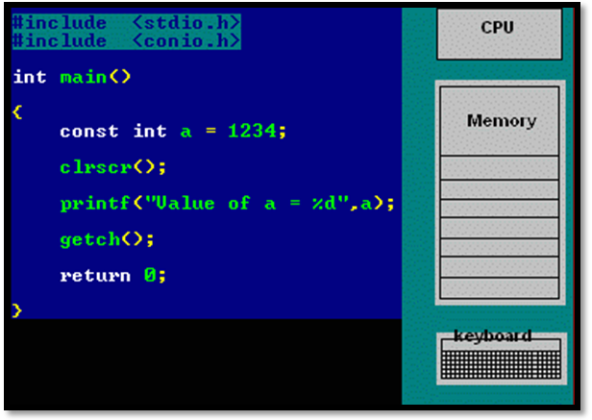
Integer constants are whole numbers without any fractional part. Thus integer constants consist of a sequence of digits. Integer constants can be written in three different number systems: Decimal, Octal and Hexadecimal.

Floating-point constants
A floating-point constant is a base-10 number that contains either a decimal point or an exponent or both. A floating-point constant can be written in two forms: Factorial form or Exponential form.

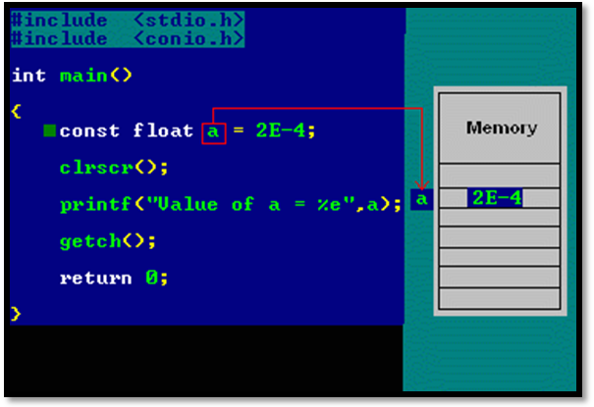

Character constants
A character constant is a single character, enclosed in single quotation marks.
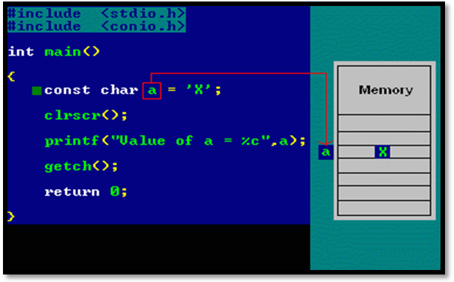

String constants
A string constant consists of zero or more character enclosed in quotation marks. Several string constants are given below.
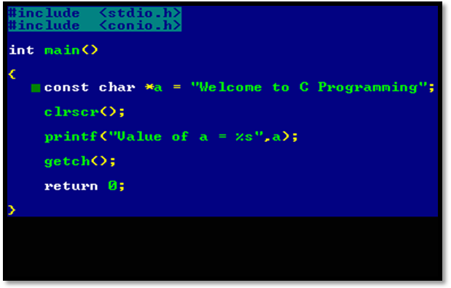

Identifiers
Identifiers are the names that are given to various program elements such as variables, symbolic constants and functions.Variable or function identifier that is called a symbolic constant name.
Identifier can be freely named, the following restrictions.
- Alphanumeric characters ( a ~ z , A～Z , 0～9 ) and half underscore ( _ ) can only be used.
- The first character of the first contain letters ( a ~ z , A～Z ) or half underscore ( _ ) can only be used.
- Case is distinguishable. That is, word and WORD is recognized as a separate identifier.
- Reserved words are not allowed. However, part of an identifier reserved words can be included.
Here are the rules you need to know:
1. Identifier name must be a sequence of letter and digits, and must begin with a letter.
2. The underscore character (‘_’) is considered as letter.
3. Names shouldn't be a keyword (such as int , float, if ,break, for etc)
4. Both upper-case letter and lower-case letter characters are allowed. However, they're not interchangeable.
5. No identifier may be keyword.
6. No special characters, such as semicolon,period,blank space, slash or comma are permitted
Keywords
Keywords are standard identifiers that have standard predefined meaning in C. Keywords are all lowercase, since uppercase and lowercase characters are not equivalent it's possible to utilize an uppercase keyword as an identifier but it's not a good programming practice.
Points to remember
1. Keywords can be used only for their intended purpose.
2. Keywords can't be used as programmer defined identifier.
3. The keywords can't be used as names for variables.
The standard keywords are given below:
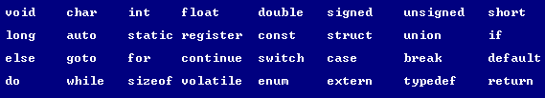

Data Types
C offers a standard, minimal set of basic data types. Sometimes these are called "primitive" types.
The C language defines 4 fundamental data types:
character (char)
integer (int)
floating-point (float)
double floating-point (double)
Type | Storage size | Value range
char | 1 byte | -128 to 127 or 0 to 255
int | 2 or 4 bytes | -32,768 to 32,767 or -2,147,483,648 to 2,147,483,647
float | 4 byte | 1.2E-38 to 3.4E+38 | 6 decimal places
double | 8 byte | 2.3E-308 to 1.7E+308 | 15 decimal places
Example :
#include <stdio.h>
#include <limits.h>

int main()
{
printf("Storage size for int : %d \n", sizeof(int));

return 0;
}

#include <stdio.h>
#include <float.h>

int main()
{
printf("Storage size for float : %d \n", sizeof(float));
printf("Minimum float positive value: %E\n", FLT_MIN );
printf("Maximum float positive value: %E\n", FLT_MAX );
printf("Precision value: %d\n", FLT_DIG );

return 0;
}

Operators
An operator is a symbol that tells the compiler to perform specific mathematical or logical manipulations. C language is rich in built-in operators and provides the following types of operators:
- Arithmetic Operators
- Relational Operators
- Logical Operators
- Bitwise Operators
- Assignment Operators
- Misc Operators
This tutorial will explain the arithmetic, relational, logical, bitwise, assignment and other operators one by one.

Arithmetic Operators
Following table shows all the arithmetic operators supported by C language. Assume variable A holds 10 and variable B holds 20 then:
Operator | Description | Example
+ | Adds two operands | A + B will give 30
- | Subtracts second operand from the first | A - B will give -10
* | Multiplies both operands | A * B will give 200
/ | Divides numerator by de-numerator | B / A will give 2
% | Modulus Operator and remainder of after an integer division | B % A will give 0
++ | Increments operator increases integer value by one | A++ will give 11
-- | Decrements operator decreases integer value by one | A-- will give 9

Relational Operators
Following table shows all the relational operators supported by C language. Assume variable A holds 10 and variable B holds 20, then:

Operator | Description | Example
== | Checks if the values of two operands are equal or not, if yes then condition becomes true. | (A == B) is not true.
!= | Checks if the values of two operands are equal or not, if values are not equal then condition becomes true. | (A != B) is true.
> | Checks if the value of left operand is greater than the value of right operand, if yes then condition becomes true. | (A > B) is not true.
< | Checks if the value of left operand is less than the value of right operand, if yes then condition becomes true. | (A < B) is true.
>= | Checks if the value of left operand is greater than or equal to the value of right operand, if yes then condition becomes true. | (A >= B) is not true.
<= | Checks if the value of left operand is less than or equal to the value of right operand, if yes then condition becomes true. | (A <= B) is true.

Logical Operators
Following table shows all the logical operators supported by C language. Assume variable A holds 1 and variable B holds 0, then:
Operator | Description | Example
&& | Called Logical AND operator. If both the operands are non-zero, then condition becomes true. | (A && B) is false.
|| | Called Logical OR Operator. If any of the two operands is non-zero, then condition becomes true. | (A || B) is true.
! | Called Logical NOT Operator. Use to reverses the logical state of its operand. If a condition is true then Logical NOT operator will make false. | !(A && B) is true.

Bitwise Operators
Bitwise operator works on bits and perform bit-by-bit operation. The truth tables for &, |, and ^ are as follows:
p | q | p & q | p | q | p ^ q
0 | 0 | 0 | 0 | 0
0 | 1 | 0 | 1 | 1
1 | 1 | 1 | 1 | 0
1 | 0 | 0 | 1 | 1
Assume if A = 60; and B = 13; now in binary format they will be as follows:
A = 0011 1100
B = 0000 1101
-----------------
A&B = 0000 1100
A|B = 0011 1101
A^B = 0011 0001
~A = 1100 0011

The Bitwise operators supported by C language are listed in the following table. Assume variable A holds 60 and variable B holds 13, then:
Operator | Description | Example
& | Binary AND Operator copies a bit to the result if it exists in both operands. | (A & B) will give 12, which is 0000 1100
| | Binary OR Operator copies a bit if it exists in either operand. | (A | B) will give 61, which is 0011 1101
^ | Binary XOR Operator copies the bit if it is set in one operand but not both. | (A ^ B) will give 49, which is 0011 0001
~ | Binary Ones Complement Operator is unary and has the effect of 'flipping' bits. | (~A ) will give -61, which is 1100 0011 in 2's complement form.
<< | Binary Left Shift Operator. The left operands value is moved left by the number of bits specified by the right operand. | A << 2 will give 240 which is 1111 0000
>> | Binary Right Shift Operator. The left operands value is moved right by the number of bits specified by the right operand. | A >> 2 will give 15 which is 0000 1111

Assignment Operators
There are following assignment operators supported by C language:
Operator | Description | Example
= | Simple assignment operator, Assigns values from right side operands to left side operand | C = A + B will assign value of A + B into C
+= | Add AND assignment operator, It adds right operand to the left operand and assign the result to left operand | C += A is equivalent to C = C + A
-= | Subtract AND assignment operator, It subtracts right operand from the left operand and assign the result to left operand | C -= A is equivalent to C = C - A
*= | Multiply AND assignment operator, It multiplies right operand with the left operand and assign the result to left operand | C *= A is equivalent to C = C * A
/= | Divide AND assignment operator, It divides left operand with the right operand and assign the result to left operand | C /= A is equivalent to C = C / A
%= | Modulus AND assignment operator, It takes modulus using two operands and assign the result to left operand | C %= A is equivalent to C = C % A
<<= | Left shift AND assignment operator | C <<= 2 is same as C = C << 2
>>= | Right shift AND assignment operator | C >>= 2 is same as C = C >> 2
&= | Bitwise AND assignment operator | C &= 2 is same as C = C & 2
^= | bitwise exclusive OR and assignment operator | C ^= 2 is same as C = C ^ 2
|= | bitwise inclusive OR and assignment operator | C |= 2 is same as C = C | 2

Misc Operators ↦ sizeof & ternary
There are few other important operators including sizeof and ? : supported by C Language.
Operator | Description | Example
sizeof() | Returns the size of an variable. | sizeof(a), where a is integer, will return 4.
& | Returns the address of an variable. | &a; will give actual address of the variable.
* | Pointer to a variable. | *a; will pointer to a variable.
? : | Conditional Expression | If Condition is true ? Then value X : Otherwise value Y

Operators Precedence in C
Operator precedence determines the grouping of terms in an expression. This affects how an expression is evaluated. Certain operators have higher precedence than others; for example, the multiplication operator has higher precedence than the addition operator.
For example x = 7 + 3 * 2; here, x is assigned 13, not 20 because operator * has higher precedence than +, so it first gets multiplied with 3*2 and then adds into 7.
Here, operators with the highest precedence appear at the top of the table, those with the lowest appear at the bottom. Within an expression, higher precedence operators will be evaluated first.
Category | Operator | Associativity
Postfix | () [] -> . ++ - - | Left to right
Unary | + - ! ~ ++ - - (type)* & sizeof | Right to left
Multiplicative | * / % | Left to right
Additive | + - | Left to right
Shift | << >> | Left to right
Relational | < <= > >= | Left to right
Equality | == != | Left to right
Bitwise AND | & | Left to right
Bitwise XOR | ^ | Left to right
Bitwise OR | | | Left to right
Logical AND | && | Left to right
Logical OR | || | Left to right
Conditional | ?: | Right to left
Assignment | = += -= *= /= %=>>= <<= &= ^= |= | Right to left
Comma | , | Left to right

